Knowledge from Online Quizzes
- Bronsted Base: accepts a proton from an acid. All group 1 and group 2 metal oxides, hydroxides and hydrides are strong bases, along with metal amides (NaH, LiOH, K₂O)
- Chlorite: ClO₂⁻
- Bronsted Acid: donates a proton to a base
- A compound is a sample containing more than one element in fixed ratios. An aqueous solution, such as Na₂CrO_{4,} is a mixture of water and other substances – the ratios of substances in a mixture can be varied
- Density does not depend on the amount of substance present, like temperature it is an intensive property
- When dealing with a percentage yield, i.e. 95%, this means you need MORE of the reactant to get a certain amount of product!

Chapter 5

- In order for a reaction to occur, collisions between particles must allow bonds to break and form (in order to generate energy)
- Reaction rate increases when concentration increases or temperature
- Chemical reaction is only a transformation of matter: conservation of mass, conservation of energy, complete or partial, fast or slow
- Reactions can be based on
  - Classification: synthesis or decomposition
  - Mechanism: oxidation-reduction or acid-base (both are fast)
- The Ångström (Å): 10⁻¹⁰ m = 0.1 m = 1 Å
- Water is a polar molecule, thus a good solvent for ionic compounds, there is an excess of negative charges near oxygen and a deficit near hydrogen because oxygen is more electronegative
- High Stability: low energy state, products need to be more stable than reactants, reaction goes from high energy to low energy
- Compounds with high ionic concentration are electrolyte when in aqueous solution, they can conduct electricity, i.e. NaCl_{(s)} → Na⁺_{(aq)} + Cl⁻_{(aq)}
- Non-electrolytes are essentially undissociated; weak electrolytes dissociate to a limited extent; strong electrolytes dissociate almost completely into ions
- All soluble ionic compounds and only a relatively few molecular compounds are strong electrolytes, most molecular compounds are either nonelectrolytes or weak electrolytes
- Weaker ionic bonds dissolve more readily (i.e. NaF < NaCl < NaI, the weakest, thus the most soluble)
- Heavy metal cations, and high charged ions have low solubility (strong bonds) and therefore a precipitate occurs in a precipitation reaction, the ionic bonds in AgI are too strong to dissociate
- Solubility Guidelines for Common Ionic Solids
  - Salts of group 1 cations (exception for Lithium) and the NH₄⁺ cation are soluble
  - Nitrates, acetates, perchlorates are soluble
  - Salts of silver, lead, and mercury (I) are insoluble
  - Chlorides, bromides, and iodides are soluble
  - Carbonates, phosphates, sulfides, oxides, and hydroxides are insoluble (sulfides of group 2 cations and hydroxides of Ca²⁺, Sr²⁺, and Ba²⁺ are slightly soluble)
  - Sulfates are soluble except for those of calcium, strontium, and barium
- Covalent bonds are less susceptible to water, they have low solubility
- Barium Sulfate has a very low solubility, it is opaque to x-rays
- Water is a good solvent for both POLAR COVALENT BONDS and IONIC COMPOUNDS
  - H₂O is a polar covalent bond with strong intermolecular reactions
  - Ionic Compounds dissociate into anions and cations in water, and generate electricity as electrolytes
  - Covalent bonds dissolve, but do not dissociate into ions (no ions are present), but rather into molecules which associate themselves with water molecules, the solution remains NEUTRAL, and is a nonelectrolyte
- Redox Reactions: oxidation by oxygen
  - Loss of electrons results in oxidation (higher charge)
  - Gain of electrons results in reduction (lower charge)
  - Oxidation and Reduction ALWAYS occur together!! (it something is oxidized, something else is reduced)
  - Reducing agent is oxidized, causes other to be reduced
  - Oxidizing agent is reduced, causes other to be oxidized
- Oxidation Number/State: formal charge of an atom in a compound if all bonds are described as 100% ionic
  - Large positive oxidation state means it is a STRONG OXIDIZER (easy to be reduced)
  - Negative oxidation state means there are no oxidizing properties (but be oxidized) i.e. metal oxides/chlorides/sulfides
  - Remember to use Roman Numerals to distinguish between oxidation states and electrostatic charges
- Figure 5-9 in Text:
Compound of ion | Oxidation State
NO₃ - | +5
N₂O₄ | +4
NO₂- | +3
NO | +2
N₂O | +1
N₂ | 0
NH₂OH | -1
N₂H₄ | -2
NH₃ | -3
- Balancing Redox Reactions:
  - Identify and mass balance redox species
  - Balance electron transfer
  - Balance ionic charges with H⁺ or OH⁻
  - Balance O and H with H₂O
  - Include counterions
- The Half-Equation Method:
  - Write and balance separate half-equations for oxidation and reduction
  - Adjust coefficients in the two half-equations so that the same number of electrons appear in each half-equation
  - Add Together the two half-equations (cancelling out electrons) to obtain the balanced overall equation
- Oxidation Number Rules:
  - Atom in elemental form, # = 0
  - F ion, # = -1 (F is very electronegative, always gains electrons)
  - H, # +1, except for metal hydrides i.e. NaH (-1)
  - O, # -2, except OF₂ (+2), and with two oxygen bonds, H₂O₂ (-1)
  - Cl, Br, I, # -1
- Highest oxidation # of an element is its group #
- Redox Reactions with Organic Compounds: Refer to notes, Carbons oxidation state is calculated to be -2/3, this is “average oxidation state” of the carbons, not all three of the carbons have equal oxidation states, they are UNEQUIVALENT
- Acid Base Reactions
- Strong Acids: HCl, HBr, HI, H₂SO₄, HNO₃, HClO₄, HClO₃
- Acids: sour, litmus turns red, react with metals to produce hydrogen gas (due to hydronium cation)
  - Bronsted: acid is H⁺ donor, base is a H⁺ acceptor
  - A-H + B → A⁻ + BH⁺
  - Arrhenius: acids form hydronium ions by donating protons; bases accept proton to form hydroxide
  - Strong Acid: completely ionizes in H₂O, high hydronium concentration
  - Weak Acid: partial ionization, low hydronium concentration, chemical equilibrium
  - The strength of an acid is not related to the number of H⁺ atoms in molecules but rather the nature of the bonding
- Bases: bitter
- Strong Bases: NaOH, Group I and II hydroxides (except Mg(OH)₂), + Hydrides (NaH); Oxides of group I and group II metals also act as bases when reacting with water
  - Strong Bases: soluble metal hydroxides (good hydrogen ion acceptors)
  - Weak Bases: i.e. ammonia, NH₃, chemical equilibrium
  - Alkali Oxides and Alkali Hydrides are also basic compounds
- Neutralization: aqueous acid-base reaction, H⁺ + OH⁻ → H₂O
- Refer to Figure 23-9 regarding the “Blast Furnace”
- Chemical Composition + Heat Treatment → Steel Microstructure → Different Mechanical Properties based on Microstructure

Chapter 6 Summary From Text

- Pressure: force per unit area 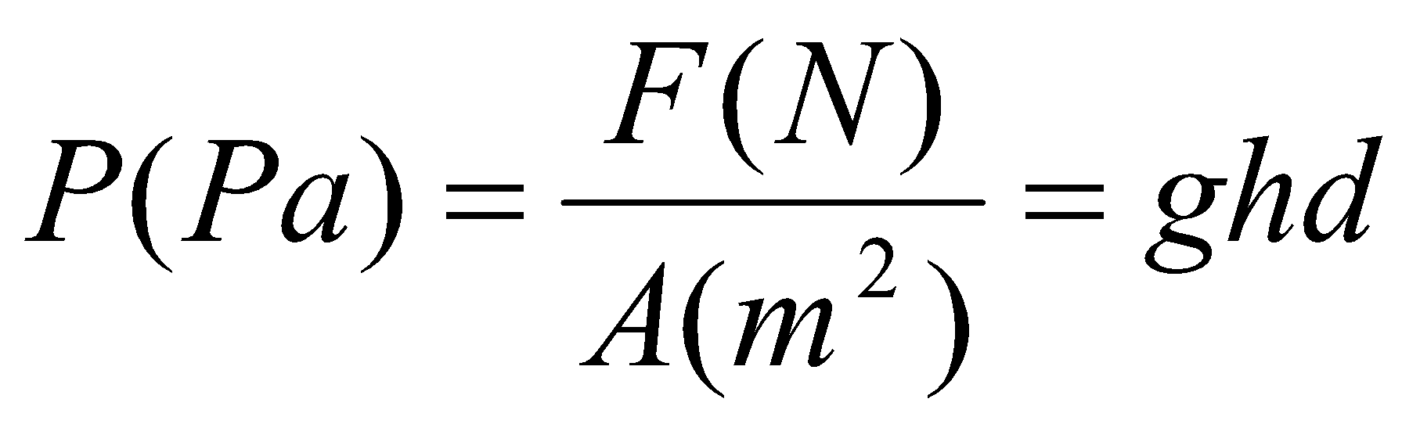, kilopascal (kPa)
- 1 atm = 760 mmHg =760 Torr = 101.325 kPa
- Boyle’s Law: For a fixed amount of gas at a constant temperature, the gas volume is inversely proportional to the gas pressure 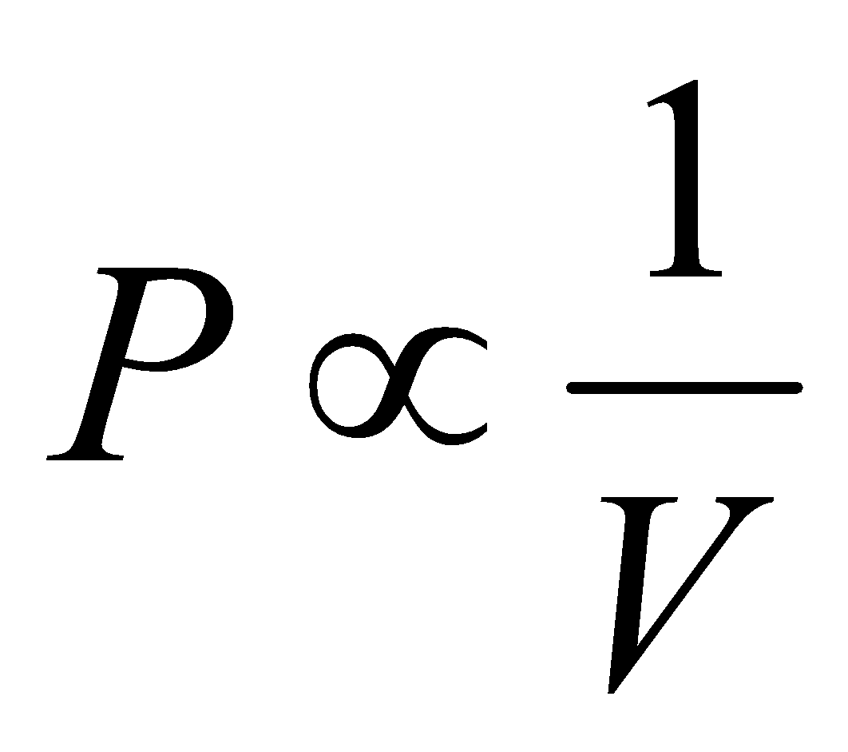
- Kelvic Scale: T (K) = t(C) + 237.15
- Charles’ Law: The volume of a fixed amount of gas at constant pressure is directly proportional to the Kelvin (absolute) temperature 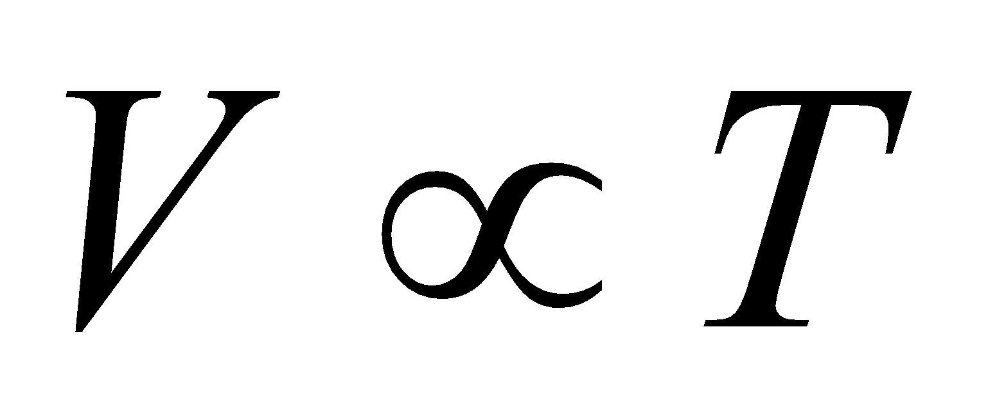
- Standard Conditions of Temperature and Pressure (STP): 273.15 K or 0 degrees Celcius
- Avogradro’s Equal volumes Equal Numbers Hypothesis: 1. Equal volumes of different gases compared at the same temperature and pressure contain equal numbers of molecules, 2. Equal numbers of molecules of different gases compared at the same temperature and pressure occupy equal volumes
- Avogadro’s Law: At a fixed temperature and pressure, the volume of a gas is directly proportional to the amount of gas
- 1 mol gas = 22.4 L gas (at STP)
- Ideal Gas Equation: PV = nRT, R is the gas constant or 8.3145 m³ Pa mol⁻¹ K⁻¹
- General Gas Equation: 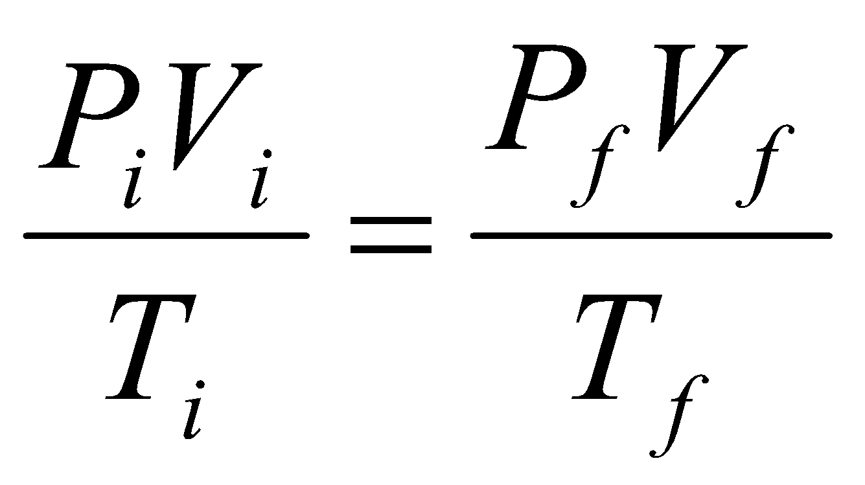 (think Peas and Vegetables on the table)
- Dalton’s Law of partial Pressures: the total pressure of a mixture of gases is the sum of the partial pressures of the components of the mixture, P_{tot} = P_{A} + P_{B}….
- Pressure, Number of Moles and Volume are Proportional for a substance: 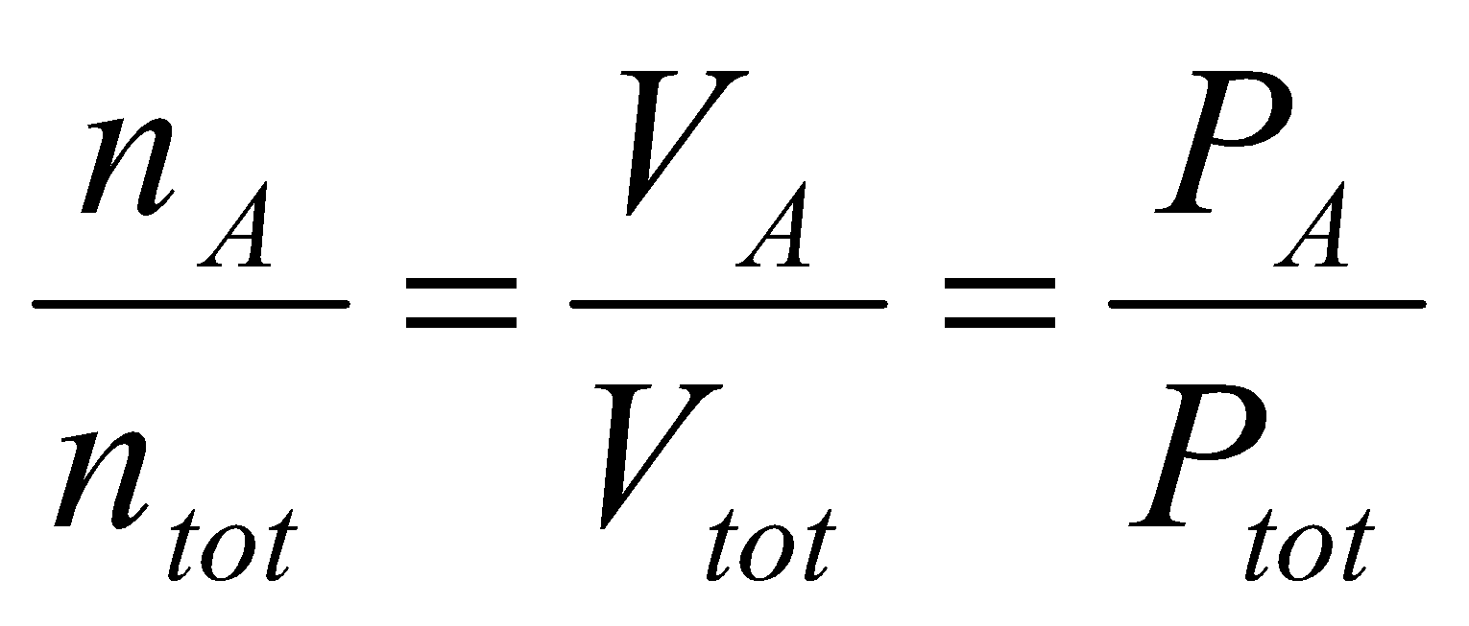
- A gas collected in a pneumatic trough filled with water is said to be collected over water and is “wet”; it is a mixture of two gases – the desired gas and water vapour (refer to chart on pg 200)
- The Kelvin temperature (T) of a gas us directly proportional to the average translational kinetic energy of its molecules
- Graham’s Law: The rates of effusion of two different gases are inversely proportional to the square roots of their molar masses
- Non-Ideal/Read Gases: Gases tend to behave ideally at high temperatures and low pressures; gases tend to behave nonideally at low temperatures and high pressures
- Van der Waals equation: 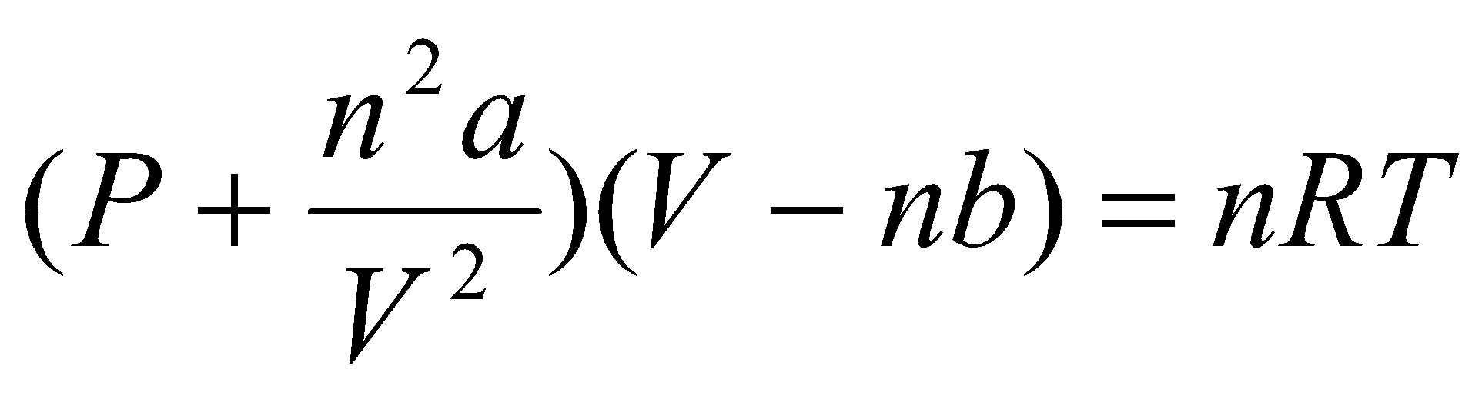

Chapter 7

- Thermochemistry: the study of energy/heat transfer during a chemical reaction
  - Loud (released) vs. Quiet
  - Emit Light (released) vs. Absorb Light (absorb photons)
  - Release heat (i.e. combustion) vs. Absorb Heat (i.e. Steel making)
- System: part of the universe chosen for study
- Surroundings: the part of the universe outside the system with which the system interact
- Closed system: does not interact with its surroundings
- Energy: capacity to do work
- Work: done when a force acts through a distance
- Chemical Energy = potential energy + thermal/kinetic energy
- Kinetic energy: energy of a moving object, based on mass and velocity, work is related to force, ½ mv², w = fd, work and energy are in joules
- Potential Energy: energy due to condition, position, or composition; associated with forces of attraction or repulsion between objects; attractive/repulsive interactions between atoms/ions/molecules (includes chemical bonds)
- Thermal Energy: kinetic energy associated with random molecular motion, proportional to the temperature of a system; atomic and molecular motion (depends on temperature), as temperature increases, the physical state of substance changes
  - Melting Point – the temperature when solid/liquid can coexist in equilibrium
  - Boiling Point – equilibrium between a liquid and gas
  - Motion can be: translation, rotation, or vibration
  - Solids have only vibration (heat transfer through vibration)
  - Liquids and Gases have translation, rotation, and vibration (heat transfer occurs through collisions/translation)
- When you lower the temperature of a substance, you freeze out the possilbity of motion (affects the mechanical state) i.e. the bending or twisting of rubber, rubber becomes brittle like ice when frozen
- Heat: energy transferred between a system and its surroundings as a result of a temperature difference; energy, as heat, passes from warmer to colder, until the average kinetic energies become the same;
- Heat Transfer: spontaneous from hot to cold (heat goes from hot source to cold source until are in equilibrium at an intermediate temperature)
- The quantity of heat, q, required to change the temp:
  - How much the temperature is to be changed
  - Quantity of substance
  - Nature of substance (type of atoms)
- 1 cal – 4.184 J
- Heat Capacity: the quantity of heat required to change the temperature of a system by one degree; if the system is mole, the term molar heat capacity applies
- q=mc∆t, positive q signifies that the system absorbs heat, negative suggests that heat is lost
- Law of Conservation of mass energy: heat gained by a system is lost by its surroundings, and v.v
- Chemical Energy: energy associated with chemical bonds and intermolecular attractions
- Heat of Reaction: the quantity of heat exchanged between a system and its surroundings when a chemical reaction occurs within the system at constant temperature, q_{rxn} (i.e. heat of combustion)
- Isolated System: exchanges no matter or energy with its surroundings
- Exothermic Reaction: produces a temperature increase in a system, gives off heat to the surroundings, heat of reaction is a negative quantity
- Endothermic Reaction: produces a temperature decrease in an isolated system or a gain of heat from the surroundings, the heat of reaction is a positive quantity
- Calorimeter: measures quantities of heat, (i.e. bomb calorimeter, suited for measuring the heat evolved in a combustion reaction, or “coffee-cup calorimeter” an isolated system)
- Pressure-Volume Work: Work involved in the expansion or compression of gases, performed by explosives and by the gases formed in the combustion of gasoline in an automobile 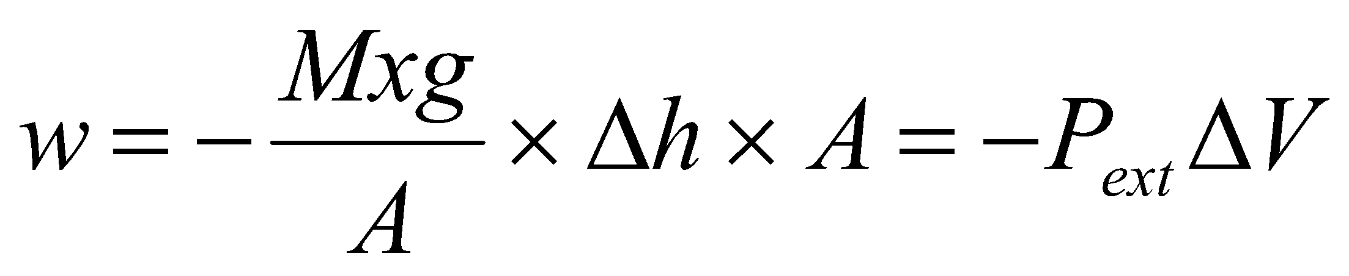, P _{ext} is external pressure, the pressure against which a system expands or the applied pressure that compresses a system
- Internal Energy, U: the total energy (both kinetic and potential) in a system, including translational kinetic energy of molecules, the energy associated with molecular rotations and vibrations, the energy stored in chemical bonds and intermolecular attractions, and the energy associated with electrons in atoms. A system contains only internal energy
- Heat and work exist only during a change in the system
- The First Law of Thermodynamics: ∆U = q + w; Internal energy (U) of an isolated system is constant
- Energy of an isolated system is constant, ∆U = 0: heat absorbed carries positive sign (w > 0), energy lost carries the negatve sign ( w < 0); internet energy of a system changes as a result of energy entering or leaving as heat or work
- Work = -P∆V, if ∆V > 0, w < 0, it is work done by system on the surroundings; if ∆V < 0, w > 0, it is work done on system by surroundings
  - The production of gas in a reaction, since the volume of products is greater than the volume of the reactants (from solid to gas), it is the expansion of a chemical system
- Work: kg. m²/s²
  - 1 kg. m²/s² = 1 J
  - 4.184 J = 1 calorie
- Transformation at Constant Volume: ∆U = q + W = q - P∆V, since there is no change in volume, then ∆U = q_{v}; the heat exchanged during a transformation at constant volume is equal to the change in internal energy
- Transformation at Constant Pressure: ∆U = q + W = q - P∆V; q = ∆U + P∆V, at constant pressure, ∆(PV) = P∆V + V∆P = P∆V; therefore q_{p} = ∆(U + PV)
- Function of State: any property that has a unique value for a specified state of a system, i.e. the internal energy of a system, or U; independent of path followed for transformation
- U = f (P, V, T) %
- Define State Function Enthalpy: H = U + PV,
  - q_{p} = ∆H, the heat exchanged during a transformation at constant pressure is equal to the change in enthalpy
- Heat and Work are not functions of state; their values depend on the path followed when a system undergoes a change
- Reversible Process: one that can be made to reverse its direction when an infinitesimal change is made in a system variable; the stepwise processes are said to be irreversible because the system is not in equilibrium with the surroundings, and the process cannot be reversed by an infinitesimal change in a system variable
- Combustion Reaction in a Bomb Calorimeter: Reactants and products are confined within the bomb, the reaction occurs at constant volume and no work is done; ∆U = q_{v}
- Most reactions, a small amount of pressure volume work is done as the system expands or contracts: ∆U = q_{p} - P∆V
- Enthalpy, H: the sum of the internal energy and the pressure-volume product of a system, a state function; H = U + PV, ∆H = ∆U + ∆PV, or if at constant pressure ∆H = ∆U + P∆V, and the heat flow for the process under these conditions is ∆H = q_{P}
- Enthalpy Change of Chemical Reactions
  - Reactions generally done at constant P, 1 atm; heat of reactions = q_{p} =∆H
  - If ∆H > 0, endothermic reaction, requires input of energy, if ∆H>>>>0 this reaction is difficult
  - If ∆H<0, exothermic reactions, reactions releases energy, if ∆H<<<<<0 this reaction is easy
  - State function: ∆H cycle = 0; ∆H (forward) = -∆H(reverse)
- Hess’ Law: ∆H (reaction) is independent of reaction path
- Standard Enthalpy off Reaction, ∆H°: the reactants and products are in their standard states
  - H = f (T,P) →∆H= f (T,P)
- Standard State: the pure element or compound at a pressure of 1 bar; elements found in their natural states
- Standard Conditions: T=298 K, P=1 atm
- Standard Enthalpy of Formation (∆H_{f}°): ∆H° for a reaction in which a compound is formed from its elements in their standard state
  - If ∆H_{f}°<< 0, then the compound is stable
  - If ∆H_{f}°>>0, compound is unstable
- Allotropes: different physical forms of the same element (i.e. carbon →graphite and diamond)
  - It requires a lot of activation energy to break bonds in diamond, there fore it is extremely hard (and slow process) to go from diamond to graphite, it is not easy to turn graphite into diamond either, thus diamonds are expensive)
- Enthalpy diagram: diagrammatic representation of enthalpy changes in a process; exothermic and endothermic reactions can be represented through such diagrams
- ∆H is an extensive property; it is directly proportional to the amounts of substances in a system; ∆H changes sign when a process is reversed
- Hess’s Law: If a process occurs in stages or steps (even if only hypothetically), the enthalpy change for the overall process is the sum of the enthalpy changes for the individual steps
- Standard Enthalpy of Formation, ∆H°_{f} : the enthalpy change that occurs in the formation of one mole of the substance in the standard state from the reference forms of the elements in their standard states
  - The standard enthalpy of formation of a pure element in its reference form is zero
- The bulk of current energy needs are met by petroleum, natural gas, and coal… “fossil fuels”
- Two Fundamental Problems of Fossil Fuel Use:
  - Fossil fuels are essentially non-renewable energy sources
  - Fossil fuels have bad environmental effects, such as causing nitrogen oxides
- Global Warming: local temperature changes, a rise in sea level, migration of plant and animal species
- Thermite Reactions: strongly exothermic reaction is driven by greater stability of product, Al₂O₃ (refer to notes)
- Calorimetry: heat transfer (q) determined from measurement of change in temperature
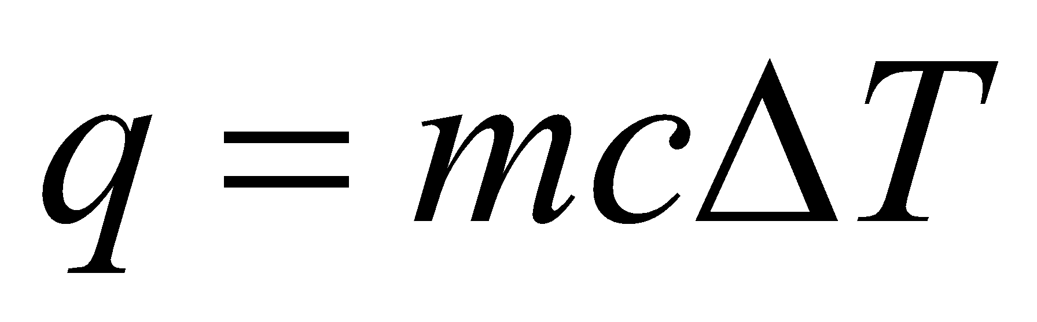
- Bomb Calorimeter: constant volume, assuming no heat loss, q=c∆T
- Attractiions lead to lower energy in products →heat is released → exothermic
- ∆H° of acid-base neutralization: assume dilute solutions equivalent to pure water, assume no heat loss (can be simplified into classic spectator ions: H⁺ + OH⁻ → H₂O)
- Heat capacity: Energy needed to raise T of substance by 1 K, can be specific (J/g/K) or molar (J/mol/K)
Chapter 8
- Ignore nucleus, focus on electron density around nucleus (not covering all of chapter 8)
- Radiation: matter-interactions (wavelength dependant) → atomic/molecular structural information
  - UV, VIS, IR absorption/emission spectroscopy (properties of bonds and e)
  - X-ray Diffractions: structure of matter (bond distances, bond angles)
- According to Maxwell (1864): light is an electromagnetic wave
  - With an oscillating electric (E) and magnetic (H) field (which are perpendicular to one another)
  - The wave propagates (V) in a direction perpendicular to both E and H

CHAPTER 8 NOTES
- Electromagnetic Radiation: a form of energy transmission in which electric and magnetic fields are propagated as waves through empty space (a vacuum) or through a medium such as glass
  - Wave: a disturbance that transmits energy; consisting of crests (high points) and troughs (low points); maximum height or depth is called the amplitude; distance between two crest is the wavelength, 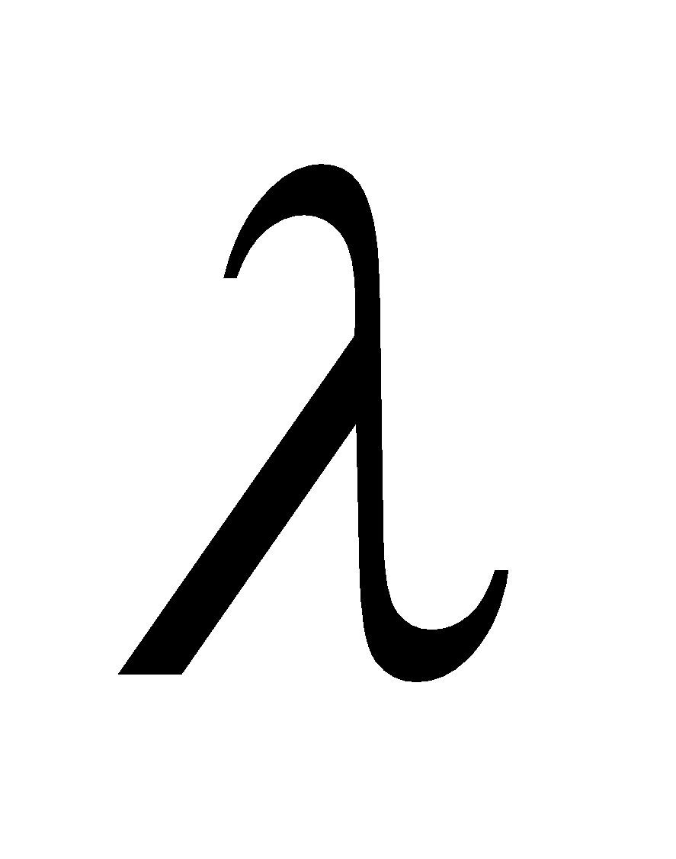
  - Frequency: the number of crests or troughs that pass though a given point per unit of time; the speed of the wave is the product of the wavelength and the frequency
  - Magnetic field component lies perpendicular to electric field component (region around an electrically charged particle)
  - Maxwell: electromagnetic radiation (electric and magnetic fields) is produced by an accelerating electrically charged particles i.e. radio waves
  - Speed of Light: 2.997 x 10⁸ m/s or 3.00 x 10⁸ m/s (in a vacuum) 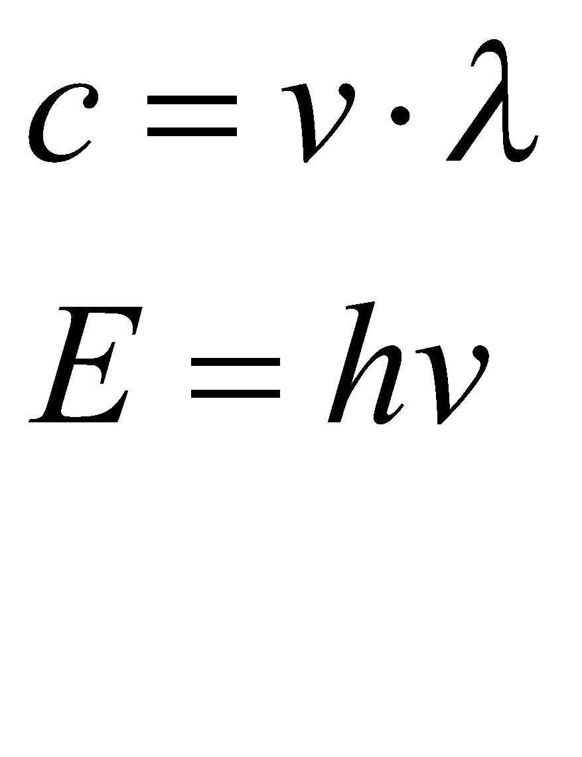
  - Constructive interference: addition of waves which are in phase, producing the highest and deepest crests and troughs; Destructive interference: cancellation of waves which are out of phase, peak and trough meet to cancel out
  - Waves of differing wavelengths have slightly differing speeds in air and other media although all electromagnetic waves have the same speed in a vacuum
- Atomic Spectra: continuous spectrum is light consisting of many wavelength components, while a discontinuous spectrum has a small number of components; emission/absorption of light by atoms depends on their electronic structure
  - Energy is recovered in the form of light
- Atomic Spectra with Discrete Emission Lines (lamba, u): discrete energy levels of atom, energy of electrons is quantized
  - Discrete emission lines → different colours → different wavelengths
- Quantum Theory: limits the amount of energy a system may possess to discrete set of specific values, called a quantum of energy
  - Planck’s Postulate: the energy of a quantum of electromagnetic radiation is proportional to the frequency of the radiation – the higher the frequency, the greater the energy. 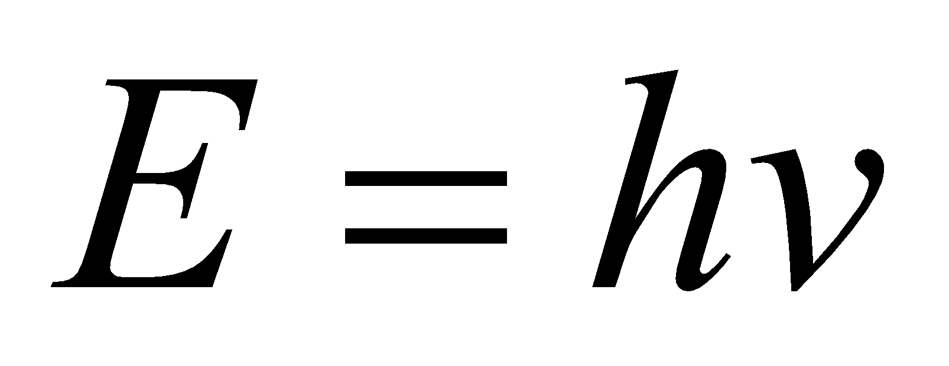, h=6.62607 x 10⁻³⁴ J s
  - Dual nature of light; radiation energy is quantized;
  - Photoelectric Effect: electron emission only occurs when the frequency of the incident light exceeds a particular threshold value, when this condition is met the number of electrons emitted depends on the intensity of the incident light but the kinetic energies of the emitted electrons depend on the frequency of the light (explained by Einstein using photon theory) 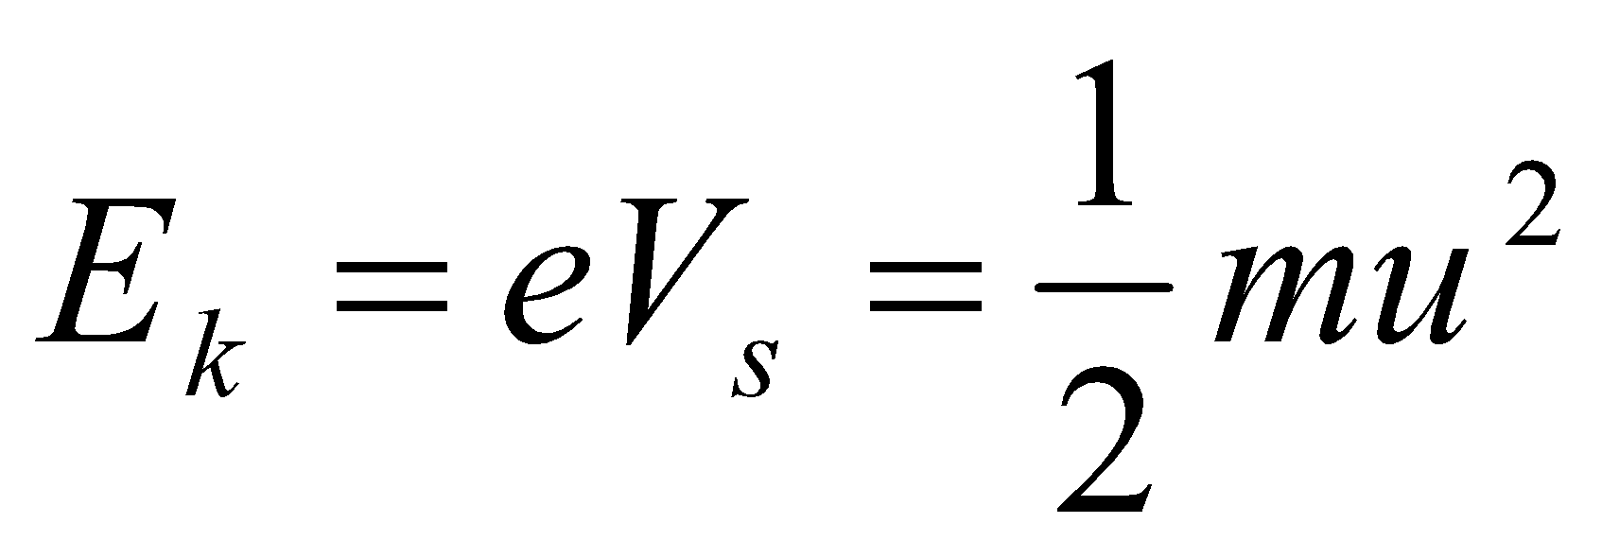
  - V_{min} for a given metal; Kinetic energy of electrons increases as v (frequency) increases); current increases as light intensity increases
  - Einstein: 1 photon extracts 1 electron
    - Energy of a photon: hv = E_{i} (metal) + E_{K} (e-)
  - Light is a stream of photons; mass less energy quantity (wave and/or photons)
  - 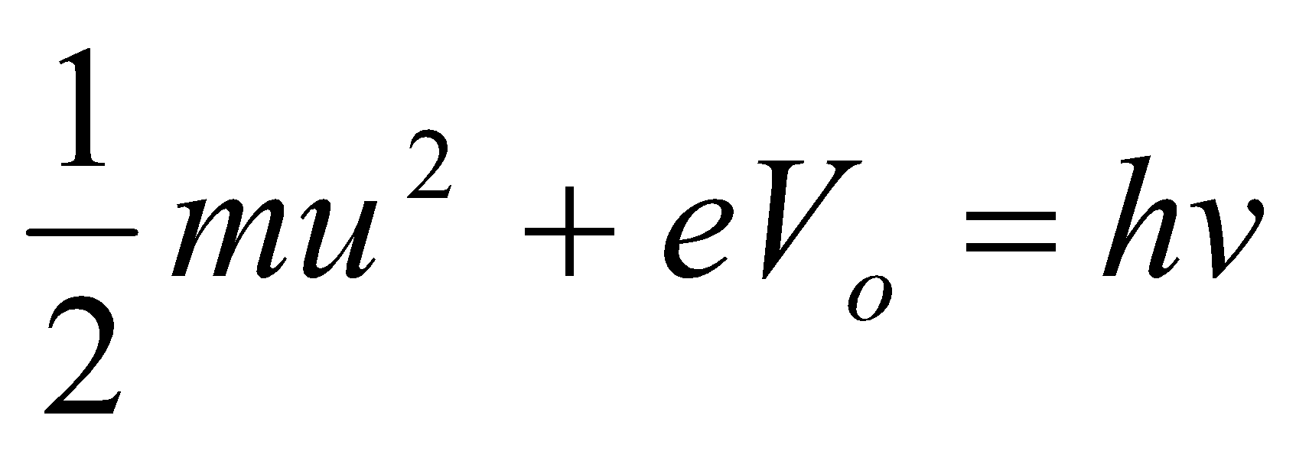
  - Photochemical Reactions: induced by light, photons as “reactants” (hv) (as flux of photons)
H2(g) + Cl2(g) — 2 HCl(g)
light
Cl2 + h  2 Cl• (initiation)
2 Cl• + 2 H2  2 HCl + 2 H•
2 H• + 2 Cl2  2 HCl + 2 Cl•
2 Cl• + 2 H2  2 HCl + 2 H• etc...
exothermic chain

reactions in upper atmosphere
O2 + h  2 O for  < 242 nm
O2 + O + N2  O3 + N2*
ozone
O3 — O2 h + O
280-315 nm (UV B)
ozone layer = UVB filter
- The Bohr Atom: the electron moves in circular orbits about the nucleus with the motion described by classical physics; the electron has only a fixed set of allowed orbits (stationary states) in which certain properties of the electron have unique values – as long as an e- remains in a given orbit its energy is constant and no energy is emitted (angular momentum); n=1 for the first orbit, n=2 for the second…; an electron can pass only from one allowed orbit to another and fixed discrete quantities of energy (quanta) are either absorbed or emitted
  - Quantum Numbers: 1, 2,3 …, integral numbers 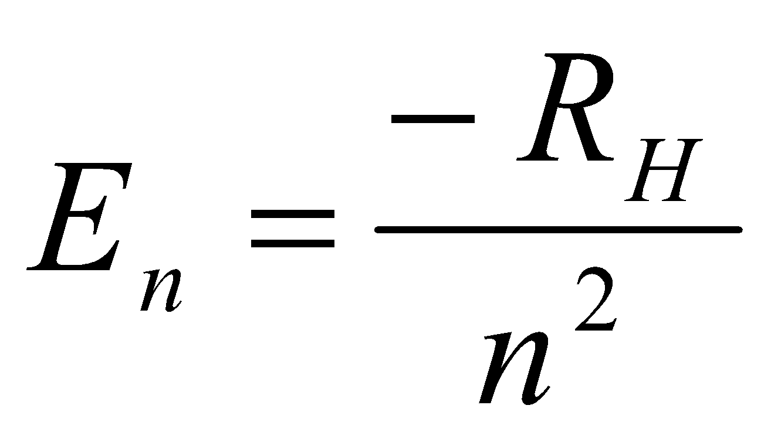
  - R_{H}=2.179 x 10⁻¹⁸ J
  - Energy different decreases as the number of the energy levels increases (recall the diagrams)
  - Ground State: lowest allowed energy
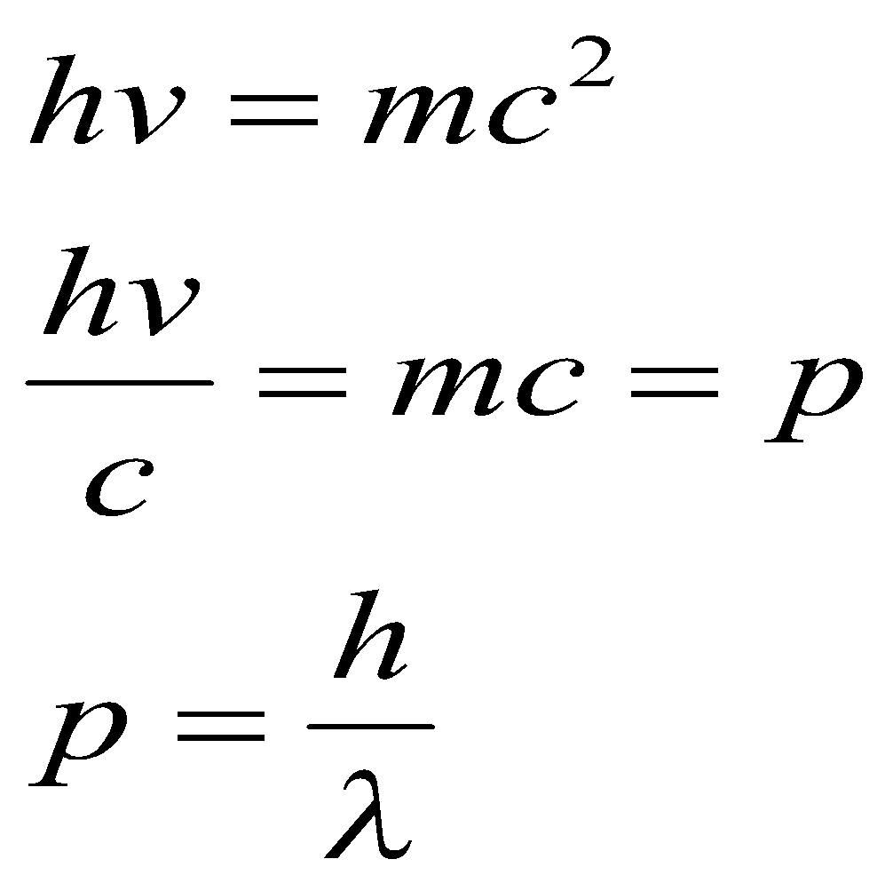
  - Exited State: when an e- gains a quantum of energy

• success of Bohr’s model
longest visible  in H emission spectrum ?
Emin = E3 - E2 = RH(1/4 - 1/9)
Emin = hmin = hc/max
max = hc/[RH(1/4 -1/9)] = 6563 Å (red)
ionization energy of H atom ?
Eion = E - E1 = RH
  - Eion = 2.179 10-18 J /atom = 1312 kJ/mol
- Wave-Particle Duality: Einstein suggested that light has particle like properties (photons)
  - Louis de Broglie: small particles of matter may at times display wave-like porpoerties 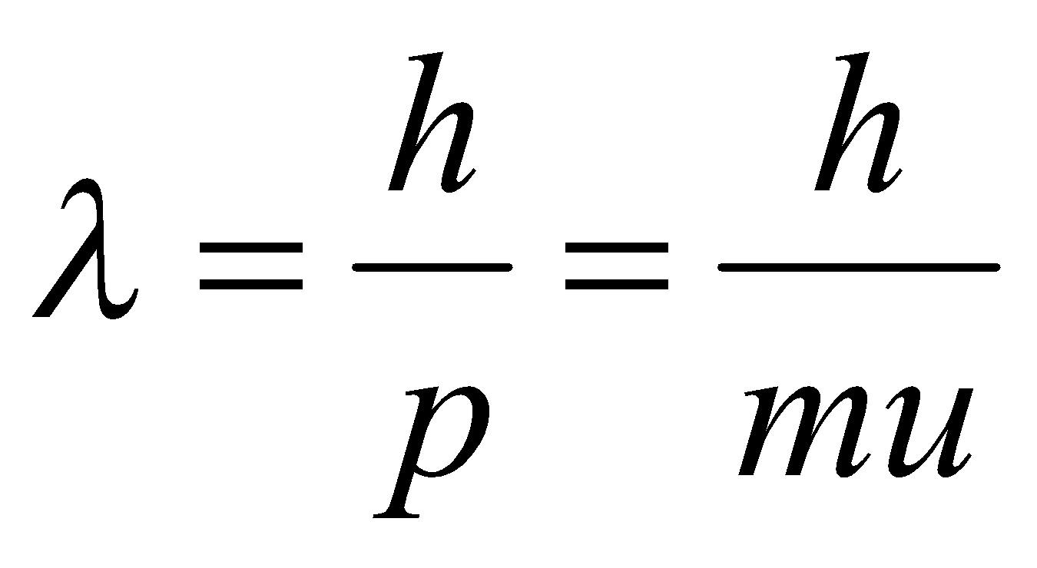 “matter waves”

- Heisenberg Uncertainty Principle: we cannot measure position and momentum with great precision simultaneously; if we know precisely where a particle is, we cannot also know precisely where it has come from or where it is going and if we know precisely how a particle is moving, we cannot also know precisely where it is. (use wave packet method)
- Electronic Transitions: upwards/downwards, atom absorbs or emits photon
  - Responsible for colour (if wavelength of photons involved is within range)
  - Colour tells us nature of chemical species
- Bohr’s model fails due to electron electron interactions; remains valid for all monoelectric species (H, He⁺, Li²⁺, etc – one electron around nucleus)
- de Broglie: wave/particle duality applicable to all moving particles
  - Momentum of photons: P=mc = hc/ , for any particle p=mv= h/
  - Diffraction experiments: interacting of matter with radiation of wavelength of an angstrom or smaller
- Heisenberg: uncertainty Principle for Microscopic Particles
  - 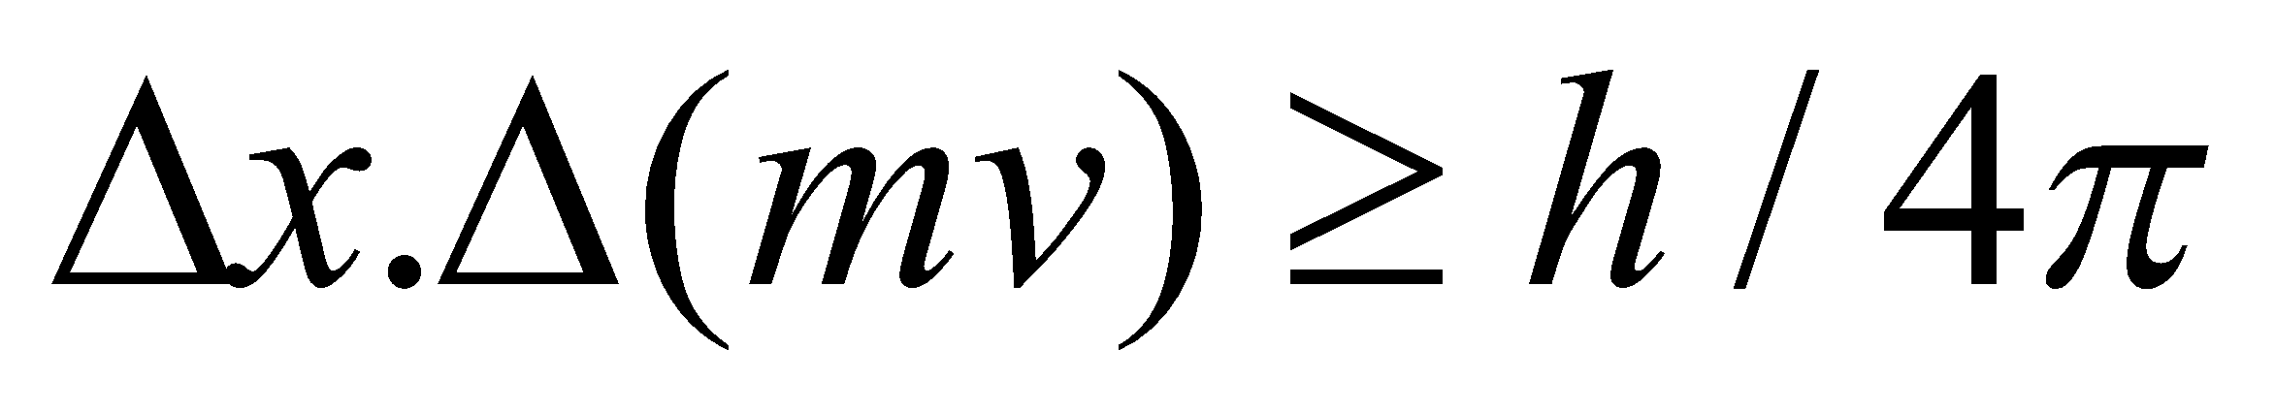 You cannot expect to measure the postion x and the momentum with the same accuracy
  - The Probability of presence of electron in orbital
  - Orbital: volume around nucleus in 3-D
  - There must always be uncertainties in measurement such that the product od the uncertainty in position, delta x, and the uncertainty in momentum, delta p is 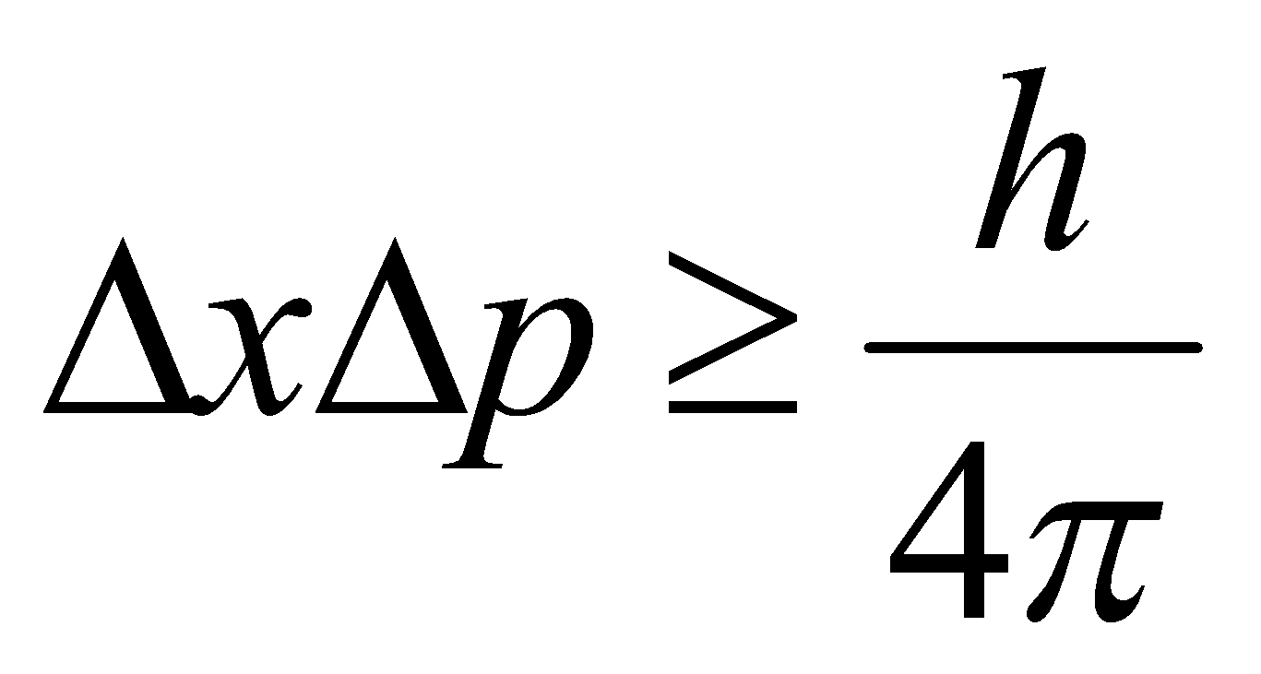
- Fundamental error or the Bohr model was to constrain an electron to a one-dimensional orbit (the electron cannot move off a circular path of fixed radius).
- Schrödinger: 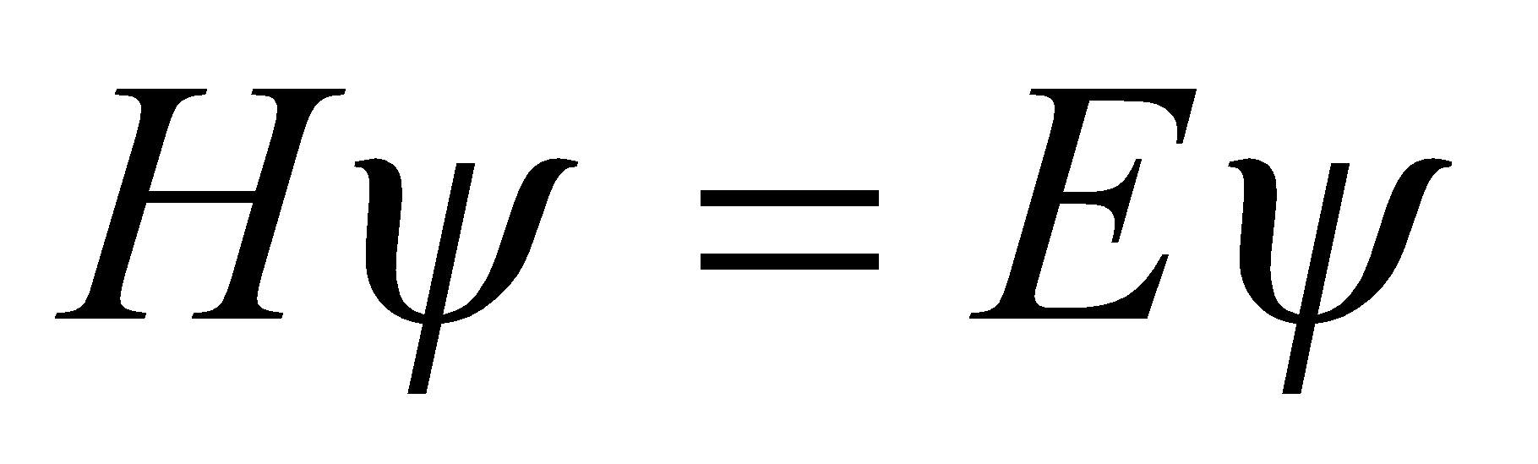, wave function, , describes electron in a given orbital (wave associated with electron);
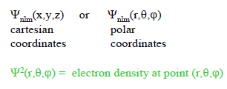
- Schrödinger Equation:
n,l,m are quantum numbers
- Quantum Numbers: n,l,m → for one wave function/atomic orbital, describe size, shape, and energy
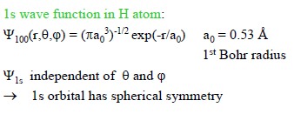
- Lowest energy level (1,0,0)
- Spherical symmetry only depends on r
- Only depends on distance, r, not angles
- R(r) is radial wave function, Y(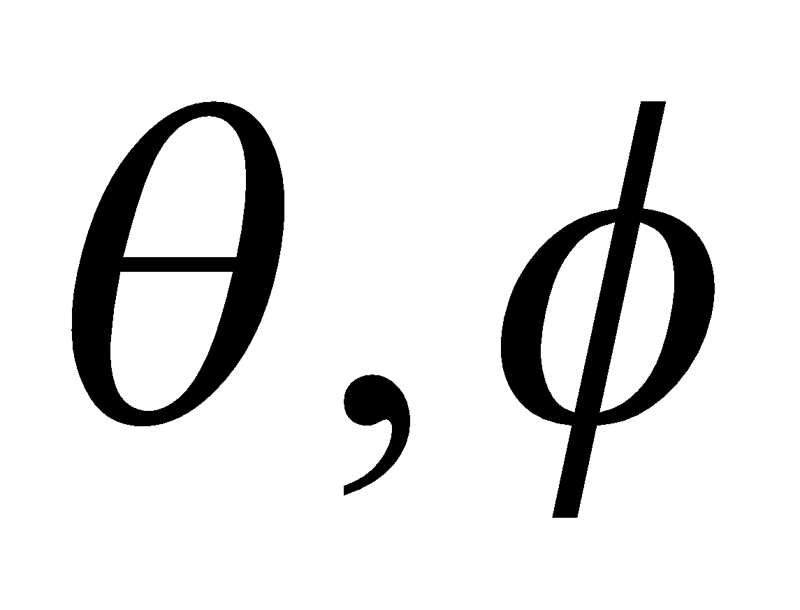) is angular wave function, each orbital has three quantum numbers since hydrogen is a 3D system
- Radial Component: spdf; angular component: 1,2,3…
- Standing Waves: have nodes, that undergo no displacement at all; wavelength of a standing wave: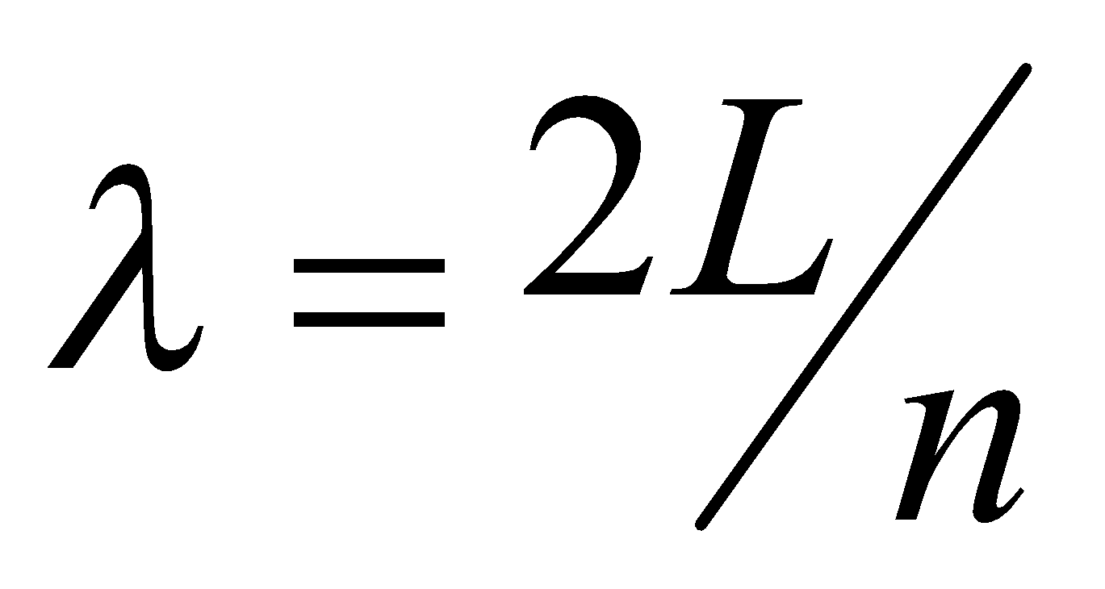 , total number of nodes = n + 1; naturally gives rise to quantization of the wave’s energy; the energy of the particle cannot be zero
- From the electron-as-particle standpoint, we have a special interest in the probability that the electron is at some particular point; from the electron-as-wave standpoint, our interest is in the electron charge density
- Quantum Numbers
  - Principle Quantum Number: n = 1,2,3,4; relates energy and most probably distance of electron from the nucleus, the value means higher energy and further from the nucleus (PHYSICAL SIGNIFICANCE)
  - Orbital Angular Momentum Quantum Number: l = n-1; determines angular distribution or shape of an orbital
  - Magnetic Quantum Number: m_{l} = -l to +l; orientation of the orbital
  - Same n values are in the same principal electron shell or same principal level
  - Same n and l values are in the same subshell or sublevel
  - Quantum numbers are ALWAYS integers
  - Number of subshells in a principal shell is equal to the principal quantum number
    - s → l=0; p → l=1; d → l=2; f → l=3
  - Number of orbitals in a subshell is the same as the number of allowed values of m_{l} for the particular value of l
    - s → l=0, m_{l}=0, one s orbital; p → l=1, m_{l}=0, +-1, three p orbitals; d → l=2, m_{l}=0, +-1, +-2, five d orbitals; f → l=3, m_{l}=0, +-1, +-2, +-3, seven f orbitals
  - All the subshells within a principal electronic shell have the same energy
  - All the orbitals within a subshell have the same energy
  - Degenerate: orbitals at the same energy level
  - n → shell
  - l → subsehll (n per shell)
  - m_{l} → orbital (2l + 1 per subshell)
- All orbitals of a given type (s,p,d, f) have the same angular behaviour, independent of the principle quantum number
- The number of nodes increases as the energy is increases
- The electron probability density of a p orbital is not spherically symmetrical (no spherical shape) – unlike s orbital
  - Angular node: arises in the angular function
- Electron Spin Quantum Number: m_{s}, value of either +1/2 or -1/2; does not depend on any of the other three quantum numbers
  - An electron generates a magnetic field, a pair of electrons with opposing spins has no net magnetic field
- Multielectron Atoms face mutual repulsion between electrons; attractive force of the nucleus for a given electron increases as the nuclear charge increases → orbital energies become lower (more negative) with increasing atomic number
  - Orbital Energies in multielectron atoms depend on the type of orbital; orbitals with different values of l within a principal shell are not degenerate
- Electrons in orbitals closer to the nucleus screen or shield the nucleus from further electrons, reducing effectiveness of attraction, effectively reduce nuclear charge
  - Magnitude of the reductionm depends on type of orbitals the inner electrons are in and screening electron
  - Radial Probability Distribution: the probability of finding the electron anywhere in a spherical shell of radius r and infinitesimal thickness, 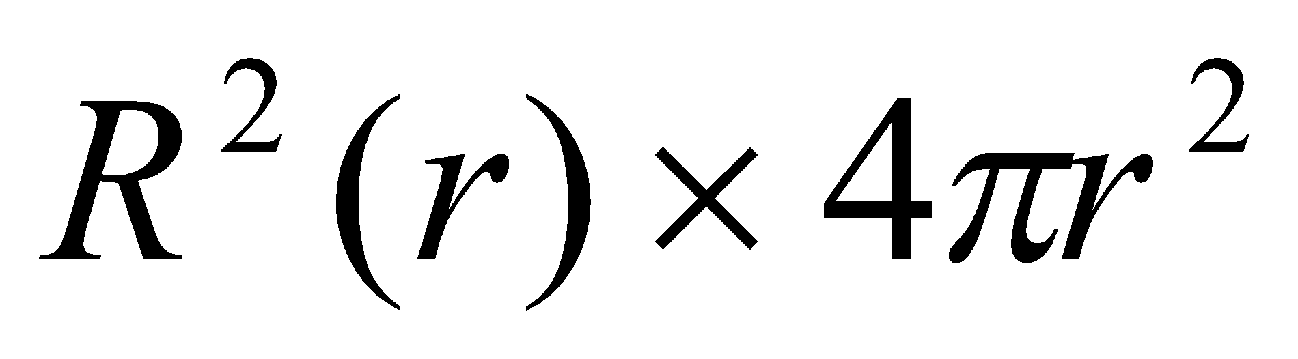
  - Gives us density of orbital at that point; tells us how much electron charge is present at radius r, centred around the surface; highest possilibity of finding electron the range is the range over which electron density exists
  - Electron in a hydrogen atom is most likely to be found 53 pm from the nucleus (radial probability distribution reaches a maximum)
  - 1s electron has a greater probability of being close to nucleus than a 2s electron, > 3s etc. 2s > 2p
  - Effective Nuclear Charge: the nuclear charge that an electron actually experiences is reduced by intervening electrons to this value
  - Less nuclear charge than an outer e- sees means smaller attraction to nucleus, therefore higher energy of the orbital in which the e is found
  - No further splitting of energies within a subshell; all orbitals have same radial characteristics
- Electron Configuration
  - Electrons occupy orbitals in a way that minimizes the energy of the atom
  - No two electrons in an atom may have all four quantum numbers alike (Pauli exclusion principle)
  - Lowest energy configuration = ground – state configuration (means its the most stable)
  - When orbitals of identical energy are available, electrons initially occupy these orbitals single (Hund’s rule)
  - Condense spdf notation denotes only the total number of electrons in each subshell; does not show how electrons are distributed
  - Elements in the same group of the table have similar electron configurations
  - Exceptions: Sr: [Kr] 5s², Al: [Ne]3s²3p¹, Ga:[Ar]3d¹⁰4s²4p¹, Tl: [Xe]4f¹⁴5d¹⁰6s²6p¹, Cr:[Ar]3d⁵4s¹, Cu:[Ar]3d¹⁰4s¹
- Only interactions that define energy of a system is between electron and nucleus for a hydrogen atom
- More negative electron staste: more stable, deeper in nucleus, harder to remove from atom
- On a the Helium Spectrum, there are more emission lines, meaning there are more energy levels in Helium than in Hydrogen (they are split energy levels)
- Outer valence configuration defines chemical properties; core electrons are “inaccessible” by chemical means
- Elements in the same period have valence electrons in same shell and therefore similar energy levels; they are arranged in a way that grouped (vertical) elements have similar valence electron configurations and similar chemical properties
- Enthalpy Change – an atom in a gas phase captures an electrons to become an ion
- Magnetic Properties are associated with structure of ions/atoms (if one ion is magnetic, then the rest is also)
  - Ferromagnetic: : “true” magnetism; complete alignment of all atoms with domains; attract iron, nickel, cobalt
  - Paramagnetic: magnetism of individual atoms; results from unpaired electrons with weak attractions
  - Diamagnetic: magnetism of individual atoms; results from paired electrons with weak repulsions.
Recall: Trends in the Periodic Table
- Effective Nuclear Charge: force of attraction between nucleus and electron (Roman Numeral Above Group). Depends on “magnitude” of atom. Increases left to right, decreases down a group.
- Atomic Radius: size of atom from centre to the further occupied energy level. As ENC increases across a row, nucleus has tighter hold on valence electrons because the number of core electrons remains constant while the number of protons in the nucleus increases hence causing a smaller nucleus. But AT increases down a group when ENC is weaker due to more screening electrons, AT decreases left to right.
- Ionization Energy: energy required to completely remove an electron from an atom, resulting in an ion. As nuclear charge increases, Ionization also increases across a row due to stronger hold on electrons. As nuclear charge decreases down a group, ionization energy also decreases because of shielding electrons and a weaker force of attraction.
- Electron Affinity: energy given off when an electron is added to an atom. Increases as size of atom decrease(energy is given off when smaller atom accepts new electron), parallels the Ionization Energy levels
- Electronegativity: electron attracting ability of the atoms in a molecule, parallels behaviour of Effective Nuclear Charge
- Ionic Radii: positive ions lose electrons, stronger nuclei hold, radius decreases. Negative ions gain electrons, weaker nuclei hold, radius increases.

